Guide 2. APT Project Development
Capstone Course

SITRAC-ANCI Project · Team: Rodrigo Ayala López and Benjamín Soto Aguilar · Advisor: María Ignacia Cobo · Client company: UltraPort
1. APT Project Progress Summary
Below you will find several fields that you must complete with the requested information.

APT project progress summary | We have developed the SITRAC-ANCI project, a system that centralizes the traceability of UltraPort’s cybersecurity incidents and aims to notify the on-duty officer within the deadlines set by Law No. 21.663 (3 hours, 72 hours and 15 days). Phase 1 was completed in the planned weeks: we defined the Product Backlog (11 user stories, based on a supporting requirements specification with 16 functional and 9 non-functional requirements) and presented the project definition. In Sprint 1 we defined and normalized the data model (20 tables, implemented with versioned Evolve migrations) and left the development environment operational.  Sprint 2 is partially completed. The backend already receives tickets via webhook, calculates and stamps the legal deadlines, evaluates their expiration in the background and exposes the information to a web prototype (the SITRAC Console, built with HTML5, CSS3 and native JavaScript, featuring an incident queue, a search box, a priority panel with SLA traffic lights and an audit history in timeline format). The backend is a REST API in .NET 8 with a layered architecture (Controller, Service, Repository) and data access with Dapper. We also modeled three process flows (incident intake and early warning, ANCI acknowledgment with reminders, and preliminary and final report), which UltraPort accepted, with some points still to be defined. The loading of catalogs and SLA rules, and the manual registration form with its approval screen, are in progress. The integration with the INVGATE API remains pending because the credentials have not been delivered, and notifications do not yet operate with the final channels and officers, although email (MailKit with Mailtrap) and Microsoft Teams (Power Automate webhooks with Adaptive Cards) delivery services already exist, developed for testing in a Sandbox environment.  The work is divided in a specialized but collaborative way: Rodrigo leads project management and regulatory compliance, designs the data model and the flows, and provides technical support on the backend and the mockups; Benjamín develops the backend and the web console, manages the database migrations with EvolveDB and takes part in architecture decisions.
Objectives | General objective (unchanged). Automate the traceability and notification of UltraPort’s cybersecurity incidents to the ANCI, ensuring compliance with the deadlines established by Law No. 21.663.  Specific objectives.  1. [ADJUSTED] Receive and centralize, via webhook, the information of the existing security incident tickets in INVGATE, leaving direct querying of its API as a future evolution, subject to the delivery of credentials. (Original: consume and centralize, through the INVGATE API, the information of the existing security incident tickets).  2. Implement a dedicated database (SQL Server, with versioned migrations through Evolve) that centralizes the traceability of incidents and their notifications to the ANCI. (Unchanged).  3. Automatically notify the corresponding on-duty officer within the critical deadlines required by regulation. (Unchanged; implementation in progress).  4. Record the evidence of each notice sent to the ANCI and of the response received, including cases dismissed as false positives. (Unchanged).  5. Deploy and document the system in an environment aligned with UltraPort’s security standards. (Unchanged).
Methodology | No adjustments. Scrum is maintained, with sprints aligned to the CAPSTONE weeks, a Trello board as the Product Backlog, Definition of Ready and Definition of Done, and the role distribution defined in Phase 1 (backlog management, regulation and coordination with UltraPort on one side; backend development on the other; and architecture design, testing and retrospectives done jointly).
Progress evidence | We selected four pieces of evidence that account for the development of the project:  1. Process flow diagrams (Figures 1 to 3). They show the design of the solution and the translation of Law No. 21.663 into rules: incident intake through five channels, 3-hour timer, personal data review and early warning (Flow 1); ANCI acknowledgment and reminders (Flow 2); and preliminary and final report (Flow 3). They correspond to the progress evidence agreed upon in Phase 1 and were accepted by UltraPort’s technical counterpart.  2. Data model and migrations (Table 1 and Figure 4). Data dictionary dated September 30, 2026, with 20 tables, 219 columns and 39 foreign keys, and Evolve scripts V0001 to V0005. They evidence the closing of Sprint 1. Subsequently, migration V0006 was added, which introduces the structure of the regulatory escalation engine (TbHito, TbReglaEscalamiento and TbNotificacionLog) to audit notices and escalations; the catalog of 17 escalation rules derived from Law No. 21.663 is integrated on top of it.  3. Solution structure and backend (Figures 4 and 5). Data access, repository and service layers, API server and web prototype, which evidence the progress of Sprint 2. The architecture is documented in a reference specification (ARCHITECTURE_REFERENCE.md). The LifecycleAdvancerService background service evaluates incidents every minute, calculates SLA expirations and advances states automatically and transactionally; concurrency is controlled with atomic transactions and database-level locks, and the Outbox pattern aims to guarantee reliable, duplicate-free delivery of alerts.  4. Demonstration video and test plan. A 90-second video showing the system working with demo cases: case queue with its legal deadlines, case detail with automatic history and the report registration window. It is complemented by a test plan for Phase 3 (30 test cases, acceptance criteria, schedule and risks), available in the repository.  We apply Scrum with Definition of Ready and Definition of Done (review by the other team member, review of the applicable non-functional requirements and a commit with a descriptive message); we maintain traceability between the specification requirements and the user stories; we version the database with Evolve migrations; we use Git/GitHub with Conventional Commits; we safeguard credentials with User Secrets and validate the configuration at application startup (ValidateOnStart); we validate the flows with the client in the coordination meetings; and we document every decision and agreement. Formal tests (unit and integration) will be run in the final sprint, according to the work plan.  Repository: github.com/gasparin2702/Capstone-Soto-Ayala  Attached evidence  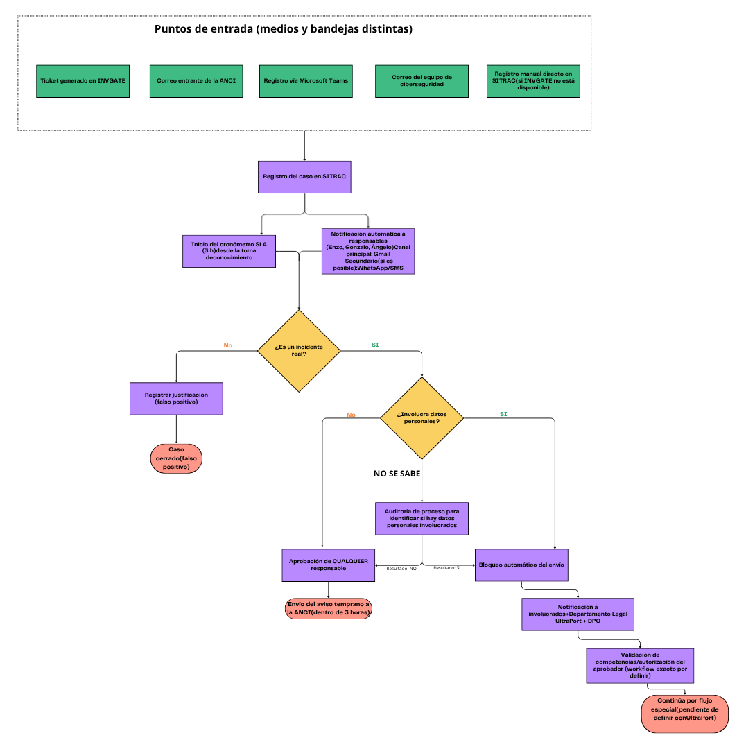  Figure 1. Flow 1: from case registration to the early warning to the ANCI. Source: own elaboration.  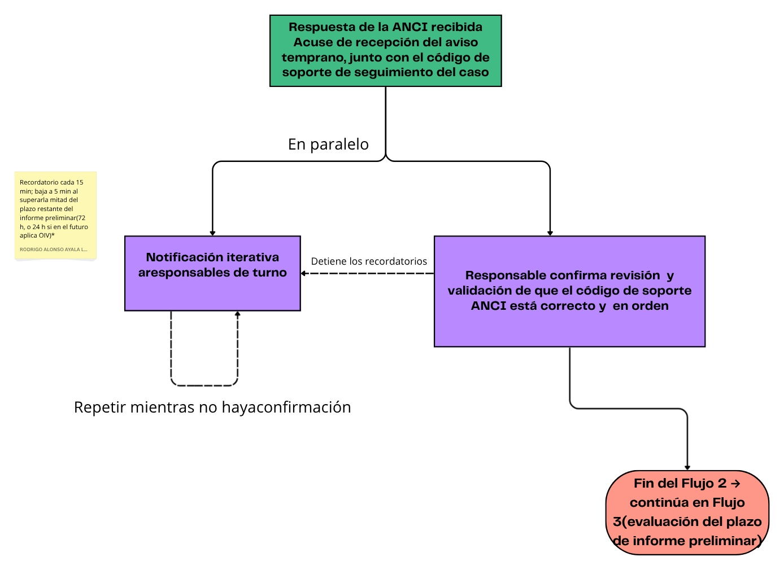  Figure 2. Flow 2: ANCI acknowledgment and iterative notification to the on-duty officer. Source: own elaboration.  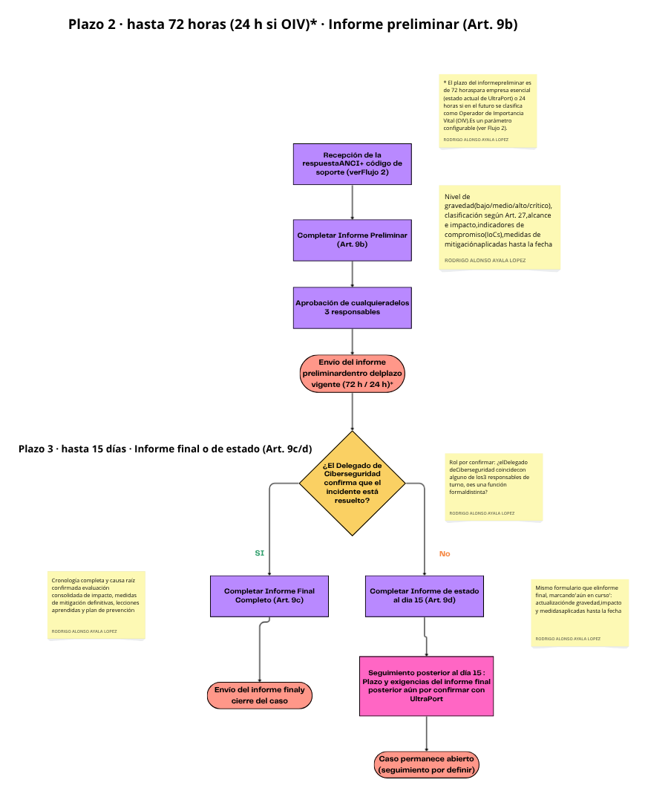  Figure 3. Flow 3: preliminary report (72 or 24 hours) and final or status report (15 days). Source: own elaboration.  Table 1. Data model summary  Source: SITRAC Data Dictionary (09-30-2026), Proyecto_SITRAC database, Microsoft SQL Server.  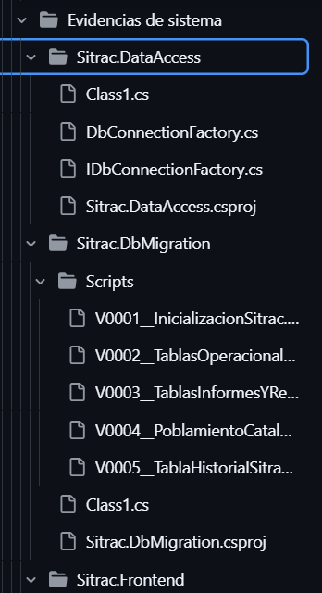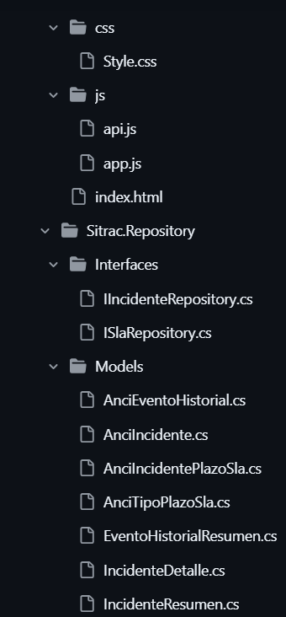  Figure 4. Solution structure: Sitrac.DataAccess, Sitrac.DbMigration (scripts V0001 to V0005), Sitrac.Frontend and Sitrac.Repository. Source: project repository.  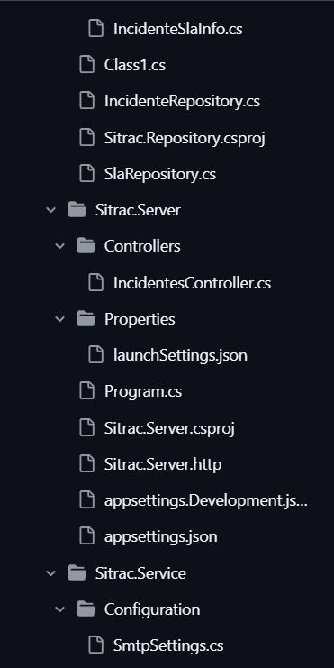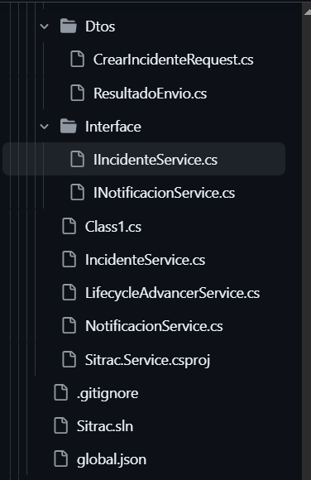  Figure 5. Solution structure (continued): Sitrac.Repository, Sitrac.Server and Sitrac.Service. Source: project repository.
  Table type | No. of tables | No. of columns | Foreign keys
  Main (incident, officer, communication, approval, report, document, notification, history) | 8 | 144 | 39
  Catalog (statuses, severity, channels, company classification, among others) | 12 | 75 | 0
  Total | 20 | 219 | 39
2. Work Plan Monitoring
Carefully examine your work plan, focusing especially on the progress status and adjustments columns.

Work Plan
Competency or competency units | Activities | Resources | Activity duration | Responsible | Remarks | Progress status | Adjustments
Requirements engineering / Project management | Definition of the Product Backlog and supporting SRS | Meeting transcripts, regulation, UltraPort templates, Trello | Weeks 1 to 3 | Rodrigo Ayala | Facilitated: weekly meetings with UltraPort. Hindered: UltraPort’s technical foundations delivered progressively. | Completed | No adjustments
Oral and written communication | Presentation of the project definition | APT Project Definition Guide, presentation material | Week 4 | Rodrigo and Benjamín | Facilitated: the team’s prior progress. | Completed | No adjustments
Data model construction | Sprint 1: UltraPort parameters, database and work environment | SQL Server, Evolve, API documentation | Weeks 5 to 6 | Benjamín and Rodrigo | The model (20 tables) was defined and normalized and the environment became operational. The internship schedule, which was a concern in Phase 1, was formalized in the center’s validation form. | Completed | No adjustments
Software development | Sprint 2 — Backend: API consumption, timer, notifications | .NET Core, Node.js, UltraPort servers | Weeks 7 to 10 | Benjamín (with support from Rodrigo) | Progress: ticket webhook, deadline calculation and stamping, background expiration evaluation (LifecycleAdvancerService), layered API with Dapper, SITRAC Console, V0006 migration of the escalation engine and email and Teams delivery services in Sandbox. Hindered: INVGATE credentials pending. In progress: catalogs and SLA rules; manual registration and approval screen. Pending: operation of notifications with the final channels and officers. | In progress (partial) | Consumption via webhook; API as a future evolution. New tasks within the sprint
Project management / Oral and written communication | Sprint Review + Progress report | Sprint Backlog, progress report template | Weeks 10 to 13 | Rodrigo and Benjamín | We have already prepared this guide and the internship progress report. The formal retrospective will be held when Sprint 2 closes. | Not started (on schedule) | No adjustments
Certification testing | Final sprint — testing, final report and presentation | Test environment, final report template, repository | Weeks 14 to 18 | Rodrigo and Benjamín | Depends on closing Sprint 2 and on UltraPort’s pending definitions. A test plan (draft) with 30 test cases has already been prepared for this phase. | Not started (on schedule) | No adjustments

3. Adjustments Based on Monitoring
Examine in depth the remarks in your work plan. Analyze the planned activities and point out which aspects facilitated or hindered the execution of the plan. Explain how you addressed and/or will address the obstacles. Finally, indicate the adjustments you made to the work plan based on this analysis.

Factors that have facilitated and/or hindered the development of my work plan:
What has facilitated development: a real and committed client; frequent coordination meetings with UltraPort’s Cybersecurity team, where business rules are validated and tests are coordinated in a Sandbox environment; an infrastructure and a technology catalog already defined by UltraPort; a clear division of roles between management and backend; the internship schedule already formalized (Monday to Thursday from 08:30 to 18:15 and Friday from 08:30 to 14:00), which removed the obstacle anticipated in the plan; and the use of Scrum, with Definition of Ready and Definition of Done.
What has hindered it: the dependence on UltraPort deliverables that arrive progressively. The INVGATE credentials are still pending, and the definitions of statuses and of some flows were only clarified in later meetings, so we had to correct some of them. Communication with the work environment has also been harder for us than communication within the team.
What we did and will do: given the lack of credentials, we decided to move forward with the webhook and leave API querying as a future evolution, with a deadline to define it; for the email and Teams channels we opted for manual registration, which does not depend on UltraPort permissions; and we document every decision and agreement, such as the warning to UltraPort about the end of support for .NET 8 at the in-person meeting on September 16. For what comes next, we will consolidate the pending queries to UltraPort into a single list and re-plan the remaining sprints according to what we do control, if necessary.

Adjusted or eliminated activities:
We did not eliminate activities or modify the schedule: we are on time to implement the new tasks at our work pace. We did adjust the scope of Sprint 2:
1. Ticket reading changed from querying the INVGATE API to receiving via webhook, because we do not have the credentials. The API remains as a future evolution.
2. The email and Microsoft Teams channels are covered with manual registration, which does not depend on UltraPort permissions.
Within Sprint 2 we incorporated two new tasks: loading catalogs and SLA rules through migrations, and the manual registration form with an approval screen. The user stories for auto-completing reports with UltraPort templates and for a contingency mechanism without INVGATE remain low priority and blocked, pending definitions from the client.

Activities not started or delayed:
Within the plan, the Sprint Review with progress report (weeks 10 to 13) and the final testing sprint (weeks 14 to 18) have not yet started and are on schedule. In Sprint 2 there are two components at risk of delay: the integration with the INVGATE API and the automatic notifications, which depend on the credentials and on UltraPort’s definitions.
We will prioritize what we control (webhook, manual registration and SLA rules); implement notifications as soon as the channels and officers are defined, starting with email as the main channel of Flow 1; formally request the credentials from UltraPort with a deadline and, if they do not arrive, document the integration as future work; and re-plan the remaining sprints if necessary, so as not to affect the MVP.

If the APT Project is a group project, in this column must state the names of those responsible for each task or activity. This will later allow the evaluation of each member to be differentiated.

